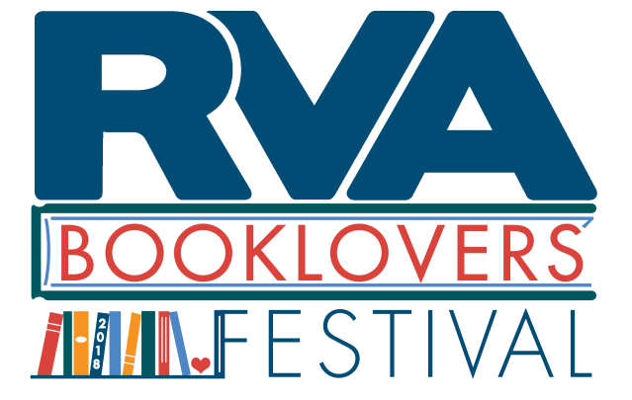
RVA Booklovers’ Festival Presenter Application
Please complete and submit by September 15, 2018.

Where: Jefferson Park
When: October 20, 2018 from 10 AM to 4 PM (setup 9 AM to 10 AM, cleanup 4 PM to 5 PM)

Name:
Email:
Phone:
Website (if any):
Professional SM pages (if any):
Titles of books you plan to bring (please include publisher name and publication date):

Have you already submitted an author booth application?
Which stage would be most appropriate for your presentation? (main stage, children’s stage, poet-tree):

Please outline your presentation proposal:

Please return via email to rvabookloversfestival@gmail.com, mail to 5. S. 1st St. Richmond, VA 23219, or fax to (804) 644-3092. We will send an invoice via email once we receive your completed application. We are happy to receive payment by check, credit card, or PayPal. You must submit payment to reserve a spot and be assigned a booth number.
Please note: there will be no electricity or Wifi provided at this event.

