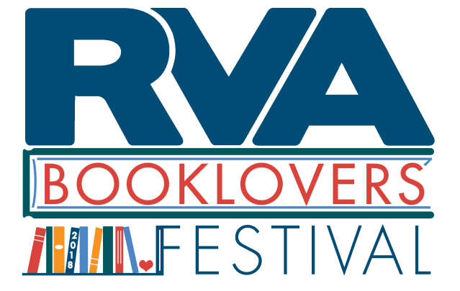
RVA Booklovers’ Festival Vendor Application
Please complete and submit by September 30, 2018.

Where: Jefferson Park
When: October 20, 2018 from 10 AM to 4 PM (setup 9 AM to 10 AM, cleanup 4 PM to 5 PM)
Booth fee: earlybird rate $125 due by 9/1
regular rate $150 due by 9/30
Applications received after 9/30/18 will be considered based on availability and will incur a $25 late fee.
*Includes: one 6-foot table with booth space, two chairs, listing on festival map and website

Business name:
Contact name:
Email:
Phone:
Website (if any):
SM pages (if any):
What goods, services, or food items do you plan to vend? (Please be as detailed as possible.):

Have you ever participated in a festival before? Which?

Please return via email to rvabookloversfestival@gmail.com, mail to 5. S. 1st St. Richmond, VA 23219, or fax to (804) 644-3092. We will send an invoice via email once we receive your completed application. We are happy to receive payment by credit card, PayPal, or check (please make check payable to Brandylane Publishers, Inc.). You must submit payment to reserve a spot and be assigned a booth number.
Please note: there will be no electricity or Wifi provided at this event.

*One 6-foot table and two chairs are not included for food truck vendors

