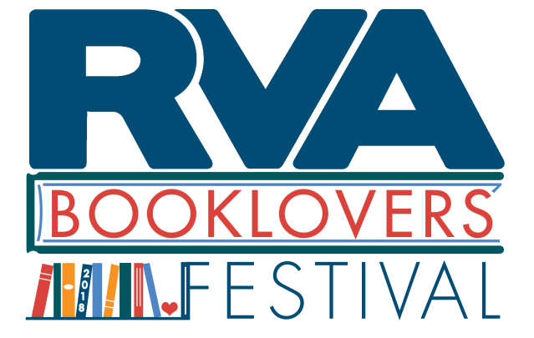
RVA Booklovers’ Festival Volunteer Application
Please complete and submit by September 31, 2018.

In order to volunteer at this event, you will be required to attend a one-hour orientation session before the Festival. Date/time TBD.

Where: Jefferson Park
When: October 20, 2018 from 10 AM to 4 PM (setup 9 AM to 10 AM, cleanup 4 PM to 5 PM)

Name:
Email:
Phone:
Previous work/volunteer experience:

Would you prefer an AM or PM shift?

Please return via email to rvabookloversfestival@gmail.com, mail to 5. S. 1st St. Richmond, VA 23219, or fax to (804) 644-3092.
Please note: there will be no electricity or Wifi provided at this event.

